1. When I launched the app through Appium below is landing page,

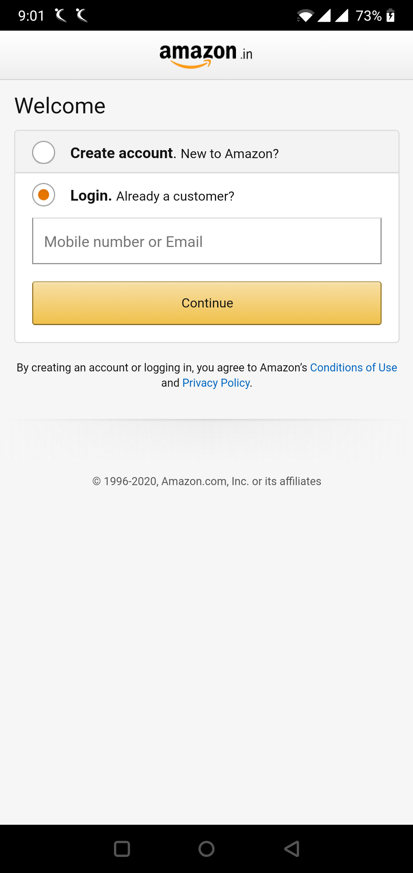

1. As mentioned in the Mail,
2. After Launching
3. I clicked on humburger Menu
4. Then clicked on setting tab
5. Then Navigated to Country/region and selects Australia as country

As per below Screenshot.

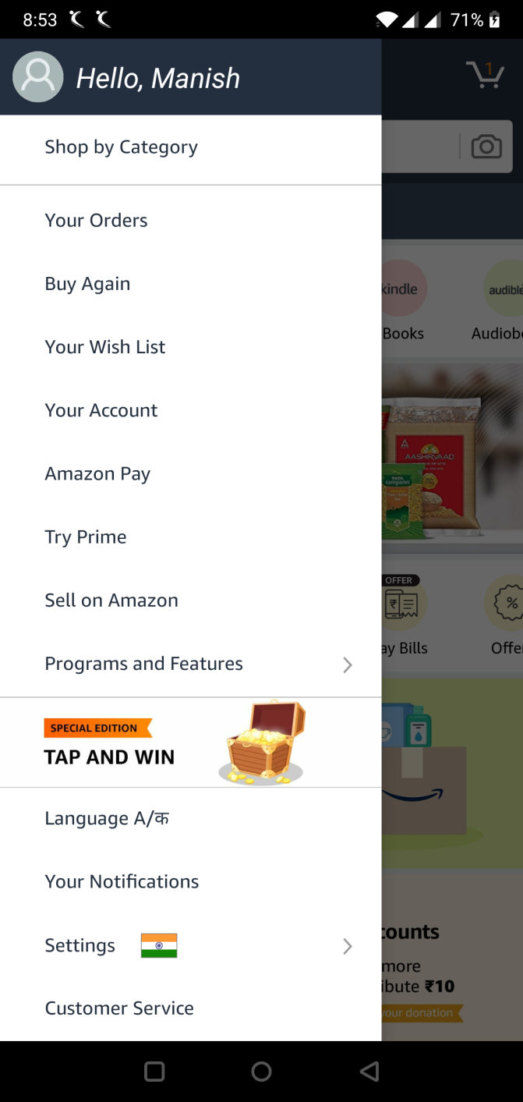

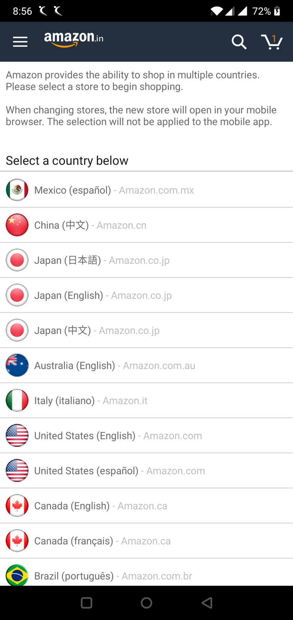

1. Then I start Searching TV.
2. 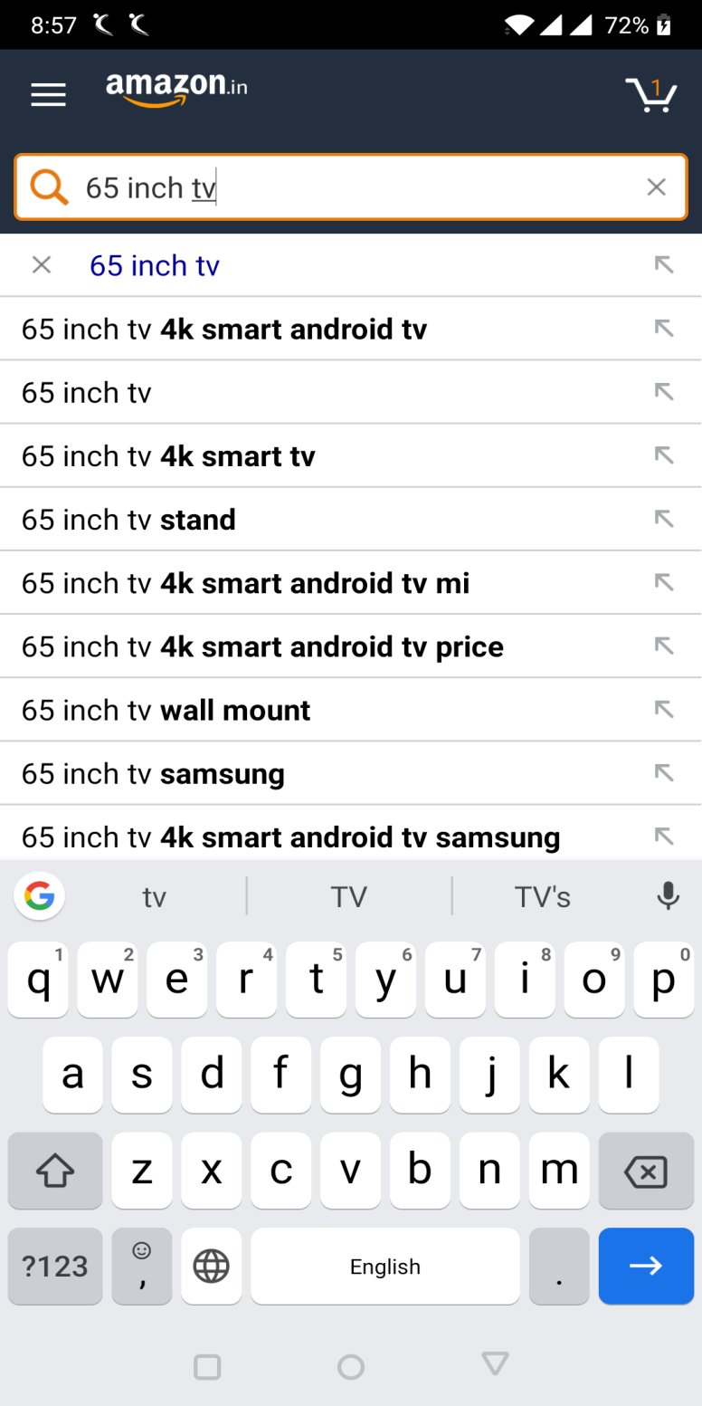
3. After this I have clicked on second link.

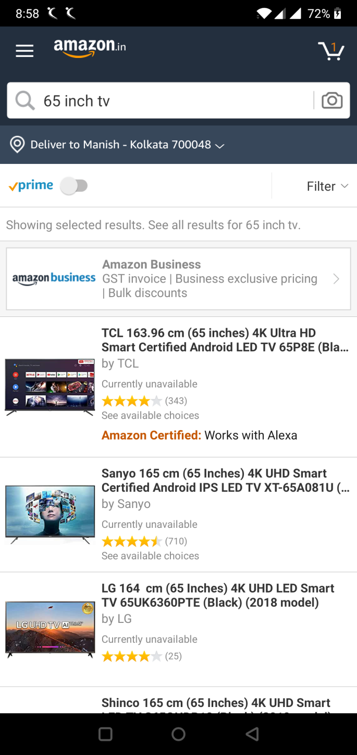

But there is no add to cart link(due to covid 19 situation)

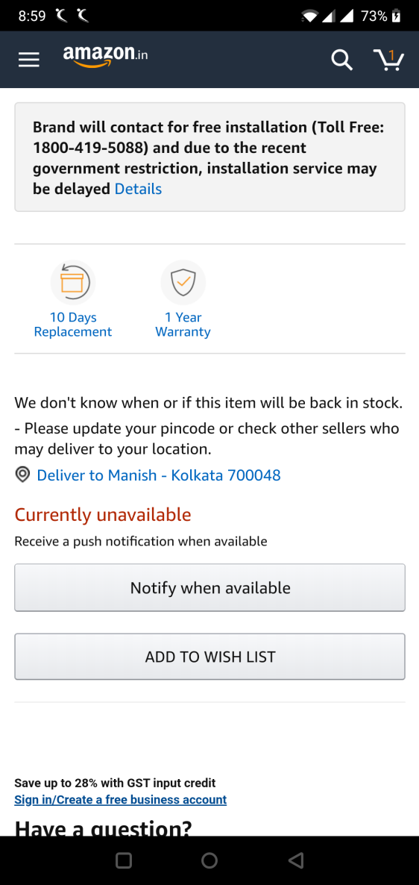

But still as I had one object added I my cart I have created page object for cart page.

